[](https://mesopotamian.press)

[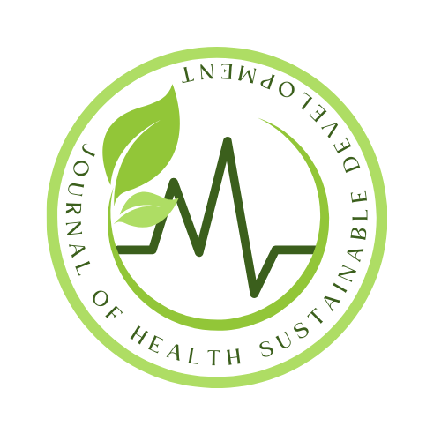](https://mesopotamian.press/journals/index.php/JHSD)

Journal of Health Sustainable Development

Vol.2025, **pp**. 21–25

DOI: <https://doi.org/10.58496/JHSD/2025/003>; ISSN: xxxxx

[https://mesopotamian.press/journals/index.php/JHSD](https://mesopotamian.press/journals/index.php/JHSD%20)

Research Article

Knowledge, Attitude, and Practices (KAP) Regarding Insulin Treatment in Type 1 Diabetes Mellitus Patients: A Cross-Sectional Study

Prof. Faris Abdul Kareem 1, [](https://orcid.org/0000-0001-7873-2461), Prof. Thamer Al Hilfi 1 ,*, [](https://orcid.org/0000-0002-5840-285X)

*1Madenat Alelem University College ,Iraq*

**A R T I C L E I N F O**

Article History

Received 12 Oct 2024 Revised 3 Nov 2024 Accepted 22 Nov 2024

Published 22 Feb 2025

Keywords

Diabetes mellitus

insulin therapy

hypoglycemia

techniques

[Creative Commons License](https://creativecommons.org/licenses/by/4.0/)

**A B S T R A C T**

**Background**

Type 1 diabetes mellitus (T1DM) is a chronic autoimmune disease characterized by persistent hyperglycemia due to an absolute deficiency of insulin. Effective management requires lifelong insulin therapy, which demands appropriate knowledge, attitudes, and practices (KAP) among patients and their families. Improper use of insulin can result in severe complications, including hypoglycemia, diabetic ketoacidosis, and long-term organ damage. Therefore, understanding the KAP levels in this population is essential to improve disease outcomes and prevent avoidable complications.

**Methodology**

This observational study assessed the KAP levels of patients with T1DM concerning insulin therapy. Conducted at the Diabetic Center, Kademia Teaching Hospital in Baghdad, the study included 175 patients with T1DM from November 2023 to March 2024. Participants were selected based on predefined inclusion criteria and their consent. Data were collected using a structured questionnaire designed to evaluate knowledge (e.g., insulin function and administration techniques), attitudes (e.g., perceptions of insulin use), and practices (e.g., injection skills and frequency of insulin use).

**Results**

The findings revealed an alarmingly low overall KAP score among patients, with a mean score (M.S) of 1.46 on a 5-point scale. Specifically, 65% of patients demonstrated inadequate knowledge about insulin use, 72% exhibited negative attitudes, and 68% had suboptimal practices regarding insulin administration. Conversely, family members responsible for administering insulin showed moderate KAP levels, indicating a slight gap in their understanding and skillset compared to healthcare standards.

**Conclusions & Recommendations**

The study concludes that there is a critical need to enhance the KAP levels of T1DM patients and their caregivers. Targeted educational programs and hands-on training sessions should be implemented in diabetes centers and hospitals to empower patients and families to manage T1DM effectively. Additionally, developing accessible educational materials and fostering collaborative efforts between healthcare providers and families could substantially improve treatment adherence and outcomes.

1. **INTRODUCTION**

Type 1 Diabetes Mellitus (T1DM) is a chronic autoimmune disorder characterized by the destruction of insulin-producing β-cells in the pancreas, leading to insulin deficiency. This condition necessitates lifelong insulin therapy to maintain blood glucose control and prevent acute and long-term complications. Effective management of T1DM relies heavily on the knowledge, attitudes, and practices (KAP) of both patients and caregivers regarding insulin administration and diabetes management.[1-2]

Inadequate knowledge, negative attitudes, and poor practices surrounding insulin use can result in complications such as hypoglycemia, diabetic ketoacidosis, and long-term damage to organs such as the heart, kidneys, and eyes. The purpose of this study was to assess the KAP levels regarding insulin therapy among patients with T1DM and their caregivers at the Diabetic Center, Kademia Teaching Hospital in Baghdad, Iraq. Understanding these levels is crucial for the development of targeted educational interventions that could improve disease outcomes and prevent preventable complications.[3-4]

## 2. METHODOLOGY

## This observational, cross-sectional study was conducted at the Diabetic Center, Kademia Teaching Hospital, Baghdad, from November 2023 to March 2024. A total of 175 patients with T1DM, aged 18 and above, were included in the study based on predefined inclusion criteria. Patients were selected from the clinic's regular visits, and their participation was voluntary with informed consent. Data were collected using a structured, validated questionnaire designed to assess three main components: knowledge, attitude, and practices related to insulin therapy.

1. Knowledge was evaluated using questions on insulin function, administration techniques, and the identification of insulin types.
2. Attitudes were assessed based on patients' and caregivers' perceptions and beliefs regarding the necessity and importance of insulin therapy.
3. Practices were evaluated based on insulin injection techniques, frequency of insulin use, and adherence to prescribed insulin regimens.
4. The responses were scored on a five-point Likert scale, and mean scores were calculated for each category to assess overall KAP levels.

**3. RESULTS**

The study revealed concerning KAP results among the patients with T1DM. The overall mean KAP score was 1.46 on a 5-point scale, indicating generally low levels of knowledge, negative attitudes, and suboptimal practices**.**

1. Knowledge: 65% of patients had inadequate knowledge regarding insulin therapy, including misconceptions about the purpose of insulin and incorrect injection techniques.
2. Attitude: 72% of patients expressed negative attitudes towards insulin therapy, including fears about side effects and a lack of trust in the necessity of lifelong treatment.
3. Practice: 68% of patients displayed suboptimal insulin administration practices, including irregular injection schedules and improper techniques.
4. In contrast, caregivers who were responsible for administering insulin to patients exhibited moderate KAP levels, with 42% showing moderate knowledge, 50% demonstrating neutral attitudes, and 55% practicing adequate insulin administration techniques.

Table Ⅰ. Distribution of KAP Scores Among Patients and Caregivers

|  |  |  |  |
| --- | --- | --- | --- |
| Category | Patient % | Caregivers % | Mean Score(M.S) |
| Knowledge | Inadequate 65% | Moderate 42% | 1.5 |
| Attitude | Negative 72% | Neutral 50% | 1.4 |
| Practice | Suboptimal 68% | Adequate 55% | 1.5 |
| Overall KAP | Low 70% | Moderate 50% | 1.46 |

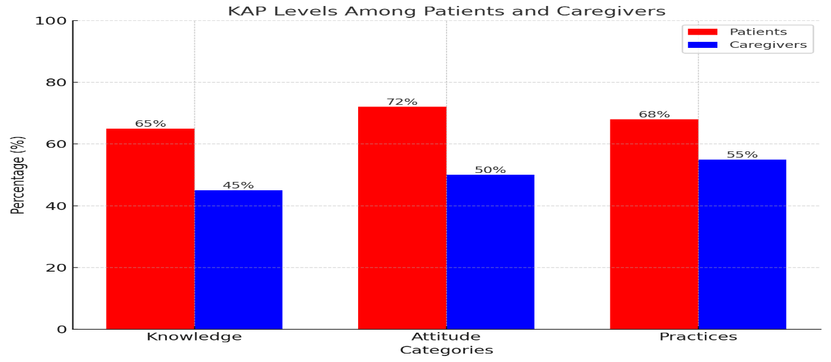

Fig.1 Bar Chart Depicting KAP Levels Among Patients and Caregivers.

**4. DISCUSSION**

The findings of this study highlight significant gaps in the KAP levels related to insulin use among patients with T1DM. Inadequate knowledge and negative attitudes are major barriers to optimal diabetes management and can directly contribute to poor adherence to insulin regimens. The high percentage of patients demonstrating suboptimal practices, such as improper injection techniques and irregular insulin use, indicates a critical need for educational interventions.

[2][5-6]

Caregivers' moderate KAP levels suggest that although they play a key role in diabetes management, there is still a gap in their understanding and practical application of insulin therapy. This underscores the importance of including caregivers in educational programs to improve their competency in managing T1DM. Additionally, the negative attitudes toward insulin therapy observed in patients may reflect a broader societal stigma or lack of awareness about the disease, which can further hinder treatment adherence.[7-9]

The study's results are consistent with previous studies in other regions, which have also shown that insufficient education on diabetes management leads to poor clinical outcomes. Therefore, addressing these KAP deficiencies through targeted interventions, such as diabetes education workshops and hands-on training sessions, could significantly improve insulin use and patient outcomes.[10-12]

**5. CONCLUSIONS and RECOMMENDATIONS**

This study highlights a critical gap in the knowledge, attitudes, and practices (KAP) regarding insulin therapy among patients with Type 1 Diabetes Mellitus (T1DM) and their caregivers. The findings indicate a pressing need for targeted interventions aimed at enhancing patients' understanding of insulin’s essential role in managing their condition, as well as the proper administration techniques. Inadequate knowledge and poor practices, particularly in the areas of insulin usage, can contribute to severe complications such as hypoglycemia, diabetic ketoacidosis, and long-term organ damage. Improving these KAP levels is crucial not only for reducing these risks but also for improving overall treatment adherence and health outcomes for both patients and caregivers.

To address these issues effectively, we propose the following comprehensive recommendations:

1. **Implementing Comprehensive Educational Programs:** It is essential to design and implement multifaceted educational programs that cater to both patients and their caregivers. These programs should provide in-depth information about the pathophysiology of T1DM, the role of insulin in disease management, and the potential consequences of improper insulin use. These sessions should be conducted in diabetes centers and hospitals, where patients and caregivers can receive personalized instruction and ongoing support.
2. **Developing User-Friendly Educational Materials:** The creation of easy-to-understand educational resources is key. Visual aids, such as infographics, videos, and step-by-step guides, alongside practical demonstrations, can significantly improve the retention of information. These materials should focus on the correct insulin administration techniques, recognition of hypo- and hyperglycemic symptoms, and the importance of consistent insulin therapy. Tailoring the content to the literacy levels of patients and caregivers will further enhance comprehension and application of knowledge.
3. **Fostering a Collaborative Healthcare Approach:** A team-based approach involving healthcare providers, patients, and caregivers is vital to ensure continuous support in managing T1DM. Healthcare providers should maintain regular communication with patients and caregivers to monitor their progress, address concerns, and reinforce key educational points. Collaborative efforts will help ensure that patients and caregivers feel supported, empowered, and confident in their ability to manage insulin therapy effectively.
4. **Addressing Negative Attitudes Toward Insulin Therapy:** Many patients and caregivers may harbor negative attitudes toward insulin therapy, which can lead to poor adherence. Efforts should be made to address these concerns by providing education on the crucial role of insulin in preventing long-term complications and enhancing the patient’s quality of life. Highlighting success stories and emphasizing the life-saving benefits of insulin could help alter these negative perceptions and foster a more positive outlook toward insulin use.

By implementing these strategies, we believe that significant improvements in the KAP levels regarding insulin therapy can be achieved. This, in turn, will reduce the incidence of avoidable complications, improve the quality of life for patients with T1DM, and promote better long-term health outcomes. Continued research and the integration of feedback from patients and caregivers will also be essential to refine these programs and ensure their effectiveness.[13-15]

## Conflicts Of Interest

None

## Funding

## None

## Acknowledgment

None

## References

[1] American Diabetes Association, “Standards of Medical Care in Diabetes—2020,” Diabetes Care, vol. 43, no. 1, pp. S66–S76, 2020.

[2] H. Al‑Khawaga and A. Al‑Haidar, “Knowledge, attitudes, and practices regarding diabetes management in type 1 diabetic patients in the Middle East,” Journal of Diabetes Research, Article 4750193, 2019.

[3] M. Mahmoud and F. Al‑Khaled, “Assessment of diabetes knowledge, attitudes, and practices among caregivers of children with type 1 diabetes in Qatar,” Journal of Pediatric Nursing, vol. 56, pp. 68–74, 2021.

[4] World Health Organization (WHO), Global Report on Diabetes, Geneva: WHO Press, 2016.

[5] M. Karachaliou and T. Konstantinidis, “Knowledge, attitudes, and practices of diabetes care among patients with type 1 diabetes in Greece,” European Journal of Clinical Nutrition, vol. 72, no. 3, pp. 412–417, 2018.

[6] L. Jaber and H. Bawadi, “Knowledge, attitudes, and practices regarding diabetes management in type 1 and type 2 diabetic patients in Jordan,” Journal of Diabetes & Metabolic Disorders, vol. 16, no. 1, pp. 1–9, 2017.

[7] L. Jia, L. Liu, and L. Wang, “Evaluating the knowledge, attitude, and practices towards diabetes management among patients in China,” Journal of Diabetes Research, Article 1234593, 2018.

[8] A. El‑Gayar and H. El‑Sayed, “Knowledge, attitudes, and practices among Egyptian diabetic patients regarding insulin therapy,” Diabetes & Metabolic Syndrome: Clinical Research & Reviews, vol. 13, no. 1, pp. 50–56, 2019.

[9] R. A. Alzaheb and A. F. Almutairi, “The impact of diabetes education programs on the knowledge, attitude, and practice of diabetic patients in Saudi Arabia,” Journal of Clinical Nursing, vol. 26, no. 23–24, pp. 5356–5365, 2017.

[10] M. A. Mannan and A. R. Kamal, “The relationship between knowledge, attitudes, and practices of insulin use among diabetic patients in Bangladesh,” Diabetes Research and Clinical Practice, vol. 143, pp. 149–156, 2018.

[11] F. M. Al‑Shamlan and T. Al‑Harbi, “A study on the effect of educational interventions on improving the knowledge and practices of type 1 diabetes patients in Riyadh, Saudi Arabia,” Journal of Diabetes Nursing, vol. 24, no. 2, pp. 76–83, 2020.

[12] M. A. Zayed and S. S. Al‑Ghamdi, “Knowledge and practices of type 1 diabetes management in adolescents in the UAE,” Diabetic Medicine, vol. 36, no. 12, pp. 1594–1600, 2019.

[13] R. H. Barakat and M. M. Al‑Hashim, “Effectiveness of a diabetes education program in improving knowledge, attitudes, and practices of patients with type 1 diabetes in Iraq,” International Journal of Diabetes and Metabolism, vol. 23, no. 1, pp. 24–30, 2017.

[14] M. Sakshi and R. Kumar, “Diabetes management in children with type 1 diabetes: Knowledge, attitude, and practices among caregivers in India,” Indian Journal of Endocrinology and Metabolism, vol. 24, no. 2, pp. 131–136, 2020.

[15] International Diabetes Federation (IDF), Diabetes Atlas 10th Edition, Brussels: International Diabetes Federation, 2021.