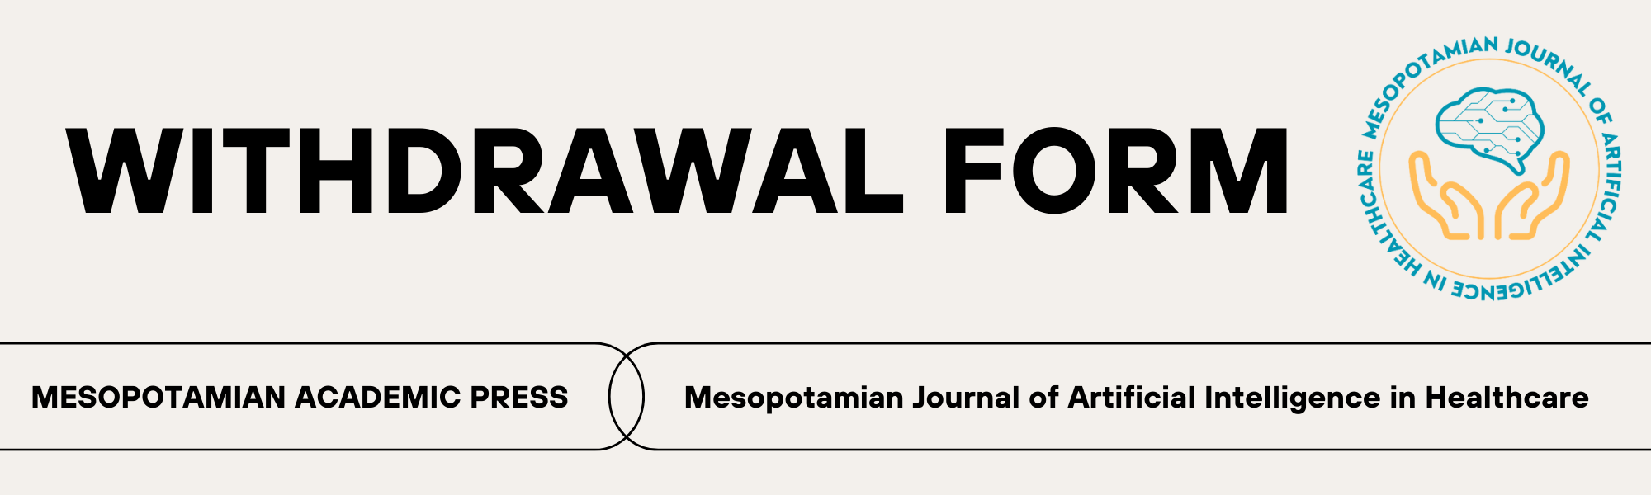
Manuscript Title
Corresponding Author
Submission Date | 10 Dec 2024
Co-Authors Information
No | Name | Affiliation | Email Address
1
2
3
4
Reason for Withdrawal
Manuscript is being submitted to another journal.
Errors or inaccuracies discovered in the manuscript.
Ethical concerns raised regarding the submission.
Co-authors do not unanimously agree on the manuscript.
Other:
(Provide a detailed explanation.)
Consent confirmation
By submitting this form, the corresponding author and all co-authors acknowledge:
All co-authors have reviewed the withdrawal request and provided explicit consent.
The withdrawal request adheres to the journal’s Publication Ethics .
No portion of the manuscript has been or will be submitted to another journal without proper disclosure and permissions.
All authors understand the consequences of unethical withdrawal, including potential sanctions by MJAIH.
Declaration and Signature
I, the undersigned, confirm that the information provided in this form is accurate and that all authors consent to this withdrawal request.
(Typed name or digital signature.) | (Enter the date of form submission.)
Signature of Corresponding Author | Date
Instructions
Complete this checklist and attach any supporting documentation when submitting a manuscript or a withdrawal request. Ensure all required forms and consents are properly documented to avoid processing delays. Submit the completed form and supporting documents to the Editor-in-Chief at aalmist1@jh.edu.
For detailed policies, visit the Publication Ethics page.




