
Conflict of Interest |  |  | 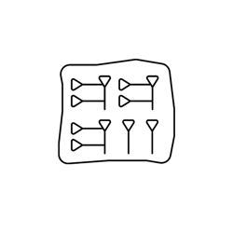
For Editorial Members

Information

Journal name
Manuscript Title
Manuscript ID [If applicable]
Date

Disclosure Form

- Financial Conflicts of Interest
Please select all that apply and provide details below: use (X) to mark your choice

Financial support or investments related to the journal or manuscript
Honoraria or other payments received from organizations related to the manuscript
Other financial interests

Details of Financial Conflicts:
[Please provide details for the selected options.]

- Personal or Professional Conflicts of Interest
Please select all that apply and provide details below: use (X) to mark your choice

Professional relationships with authors, reviewers, or institutions related to the manuscript
Personal relationships with authors, reviewers, or institutions related to the manuscript
Advisory roles or board memberships related to the manuscript
Other personal or professional relationships

Details of Personal or Professional Conflicts:
[Please provide details for the selected options.]

- Financial Interests in Related Organizations
Please indicate if you have financial interests in organizations that may benefit from the publication of this manuscript: use (X) to mark your choice

Yes
No

If yes, please provide details:
[Please provide details.]

- Other Potential Conflicts of Interest
Please describe any other potential conflicts of interest not covered above:
Other Potential Conflicts:
[Please provide details.]

- Declaration
By signing below, you confirm that you have disclosed all potential conflicts of interest related to your role and understand that any undisclosed conflicts may affect the review process or publication.
Signature: ________________________
Name: [Full Name]
Date: [Date]

